04. CNN Applications

- Object Localization

Example: for a 3-class (pedestrian, car, motorcycle) neural network, the label can be:
$$y=\left[ \begin{aligned}\begin{aligned}p_{c} \\ b_{x}\end{aligned} \\ b_{y} \\ b_{h} \\ b_{w} \\ c_{1} \\ c_{2} \\ c_{3}\end{aligned} \right] example:a car=\left[ \begin{aligned}\begin{aligned}1 \\ 0.3\end{aligned} \\ 0.6 \\ 0.2 \\ 0.2 \\ 0 \\ 1 \\ 0\end{aligned} \right] background=\left[ \begin{aligned}\begin{aligned}0 \\ ?\end{aligned} \\ ? \\ ? \\ ? \\ ? \\ ? \\ ?\end{aligned} \right] ?means "don't care"$$

Where:
$p_{c}$ : 1 means a class, 0 means background. (or the probability to have a class)
$b_{x}, b_{y}$ : the center of the class. (b means background)
$b_{h}, b_{w}$ : the height and width of the class.
$c_{1}$ : 1 if the class is a pedestrian; otherwise, 0. (or the probability to be a pedestrian when $p_{c}=1$)
$c_{2}$ : 1 if the class is a car; otherwise, 0.
$c_{3}$ : 1 if the class is a motorcycle; otherwise, 0.

If there are 80 classes, the length of the output will be 5 + 80 = 85.
$$y=\left[ \begin{aligned}\begin{aligned}p_{c} \\ b_{x}\end{aligned} \\ b_{y} \\ b_{h} \\ b_{w} \\ c_{1} \\ c_{2} \\ ⋮ \\ c_{80}\end{aligned} \right]$$

- Object Detection

The following shows how to turn fully-connected layer into convolutional layers.

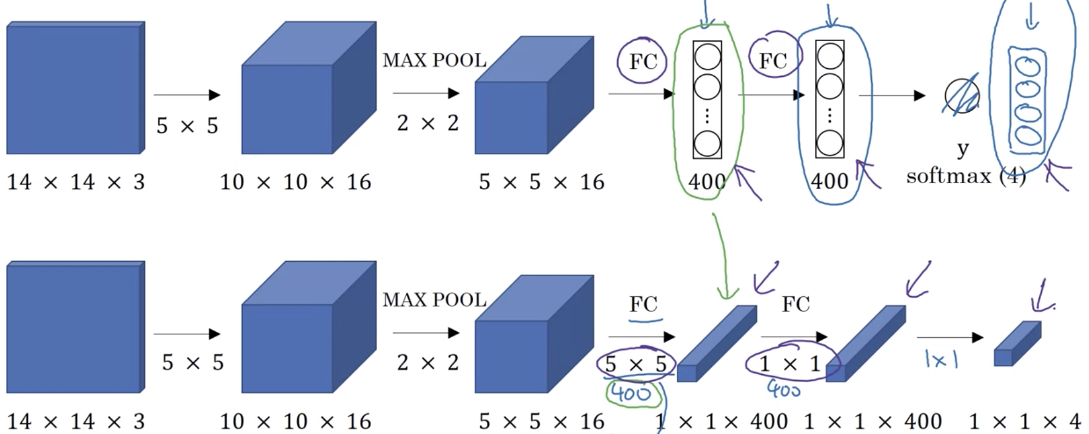

The most common approach to detect an object in an image is sliding windows detection. The following shows the convolutional implementation of the sliding windows detection algorithm. For example, given an image and the number of target grid is 8, the target output is 8 × 8 × 4.

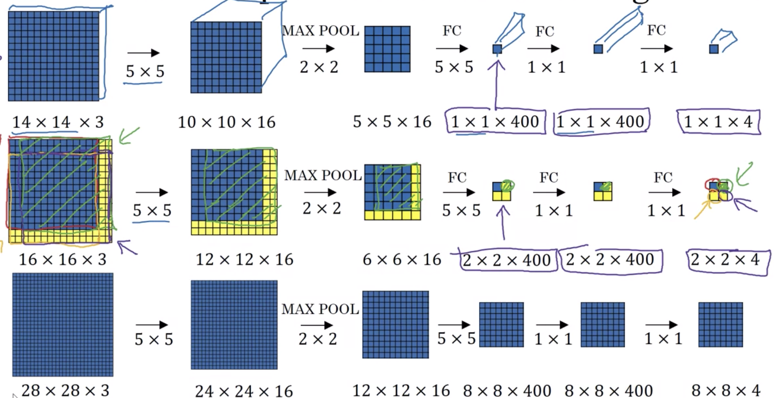

Intersection over Union (IoU)

The value of IoU is used to evaluate the object detection algorithm. Given the real bounding box of the object and the output bounding box of the algorithm,

$$IoU= \frac{area of intersection}{area of union}$$

If $IoU≥0.5$, we say the predicted bounding box is correct.

Anchor Box

Anchor box is used when a grid cell may detect multiple objects. With two or more anchor boxes, each object in the training image is assigned to the grid cell that contains the object's midpoint and the anchor box for the grid cell with highest IoU. For example, a grid cell may detect both a car and a pedestrian, and its output can be:
$$y={\left[1 b_{x} b_{y} b_{h1} b_{w1} 1 0 0 1 b_{x} b_{y} b_{h2} b_{w2} 0 1 0\right]}^{T}$$

In practice, anchor box is chosen by exploring the training data to choose reasonable height/width ratios that represent the different classes. The following shows 5 anchors represented by its width and height.
$$\left[ \begin{aligned}\begin{matrix}0.57273 & 0.67385 \\ 1.87446 & 2.06253 \\ 3.33843 & 5.47434\end{matrix} \\ \begin{matrix}7.88282 & 3.52778\end{matrix} \\ \begin{matrix}9.77052 & 9.16828\end{matrix}\end{aligned} \right]$$

- YOLO Algorithm

Example: Given an image (608, 608, 3), find the objects in that image. There are 80 classes. The output has $19×19$ grids and 5 anchor boxes. The following shows the YOLO (You Only Look Once) architecture.
Image (m, 608, 608, 3) -> Deep CNN -> Encoding (m, 19, 19, 5, 85) (or m, 19, 19, 425)

The following shows the graph.

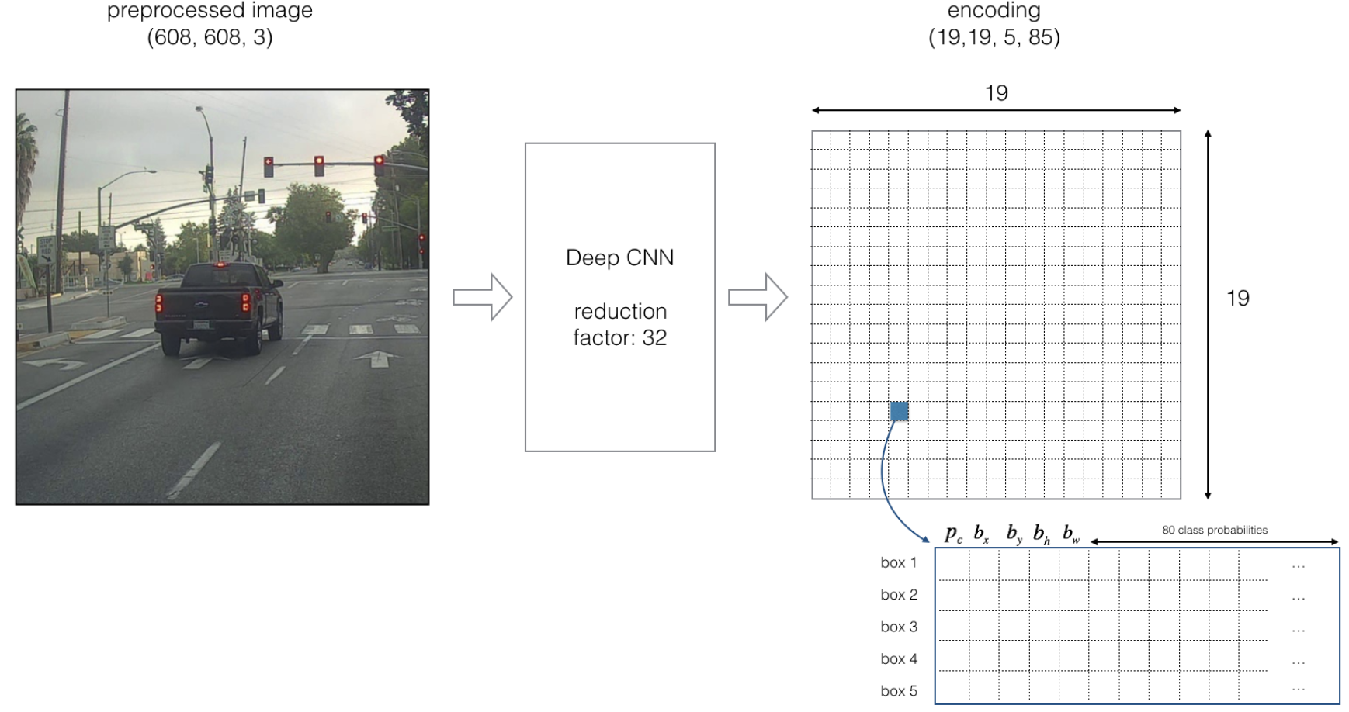

For each input $(608, 608, 3)$, the CNN gives all the predicted boxes in the output ($19, 19, 5, 85)$. You need to perform filtering and select only the best boxes.

Class Score

In practice, $p_{c}$ may be the probability that the cell contains an object, and $c_{i}$ may be the probability that the object is object $i$ when $p_{c}=1$. For each anchor box, the class score is the probability that the box contains a certain class.
${score}_{c, i}=p_{c}*c_{i}$ (element-wise multiply)

For example, for box 1, the probability that an object exists is $p_{1}=0.60$, so there is a 60% chance that an object exists in box 1. The probability that the object is $c_{3}$ (car) is 0.73. So ${score}_{1, 3}=0.60×0.73=0.44$.

For each of the $19×19$ grid cells, we can find the anchor box which has the maximum score and mark the cell with the selected object. In this way, we predict an image by visualizing classes.
- For each grid cell: (1 : 361 = 19 × 19)
For each bounding box: (1: 5)
For each class $c_{i}:$ (1: 80)
Compute class score ${score}_{c, i}=p_{c}*c_{i}$
Find the max score for the bound box. (you can draw the box using this max value)
Find the max score for the cell and mark the cell with the selected class.

Non-Max Suppression Algorithm

Another way is to use the non-max suppression algorithm.
- Given the output prediction $(19, 19, 5, 85)$.
- Discard all boxes with $score≤threshold1 (such as 0.6)$
- While there are any remaining boxes: (This is a loop)
- Pick the box with the largest score, output it as a prediction.
- Discard any remaining box with $IoU≥threshold2$ (such as 0.5) with the box output in the previous step.

For multiclass output, you need to run the algorithm independently on each output class.

There may be three things to do:
- Because the boxes are represented using midpoints and dimensions $(b_{x}, b_{y}, b_{h}, b_{w})$, you may need to convert to the left-top corner and right-bottom corner $(x_{1}, y_{1}, x_{2}, y_{2})$.
- If the YOLO model was trained on some certain images (for example, 608 × 608) and your images have a different size (for example, 720 × 1280), you need to rescale the boxes so that they can be plotted on top of your images.
- Training a YOLO model takes a very long time. You can find some existing pre-trained YOLO model online.

- Face Recognition

Face Verification means that given two images, determine if they are the same person. Face Recognition means that given a person database and an image, output a name if the image is some person in the database. One shot learning problem recognizes a person from just one example. A parameter $d$ is used to indicate the degree of difference between two images. If $d≤τ$, these two images are the same person; otherwise, they are two different persons.

Given an input $x^{(i)}$, a Siamese Network outputs an encoding $f(x^{(i)})$.
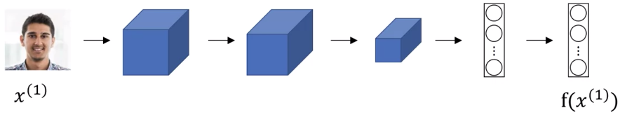

Give two images, we can determine if they are the same person by computing the distance between two encodings.
- If ${\left\|f\left(x^{\left(i\right)}\right)-f(x^{\left(j\right)})\right\|}^{2}<threshold$, they are the same person.
- Otherwise, they are different persons.

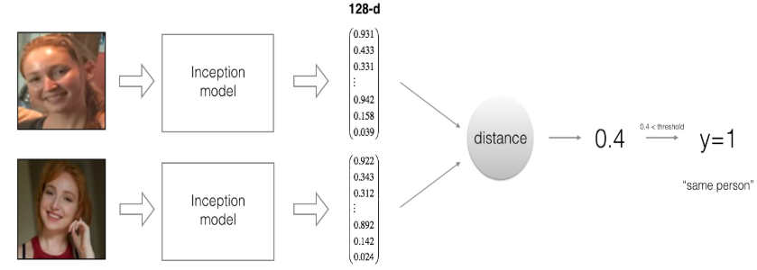

- Triplet Loss

Given three images: the original image (anchor) $A$, an image of the same person (positive) $P$, and an image of a different person (negative) $N$, we define the loss function as below. The parameter $α$ is called the margin.
$L\left(A, P, N\right)=\max\left({\left\|f\left(A\right)-f\left(P\right)\right\|}^{2}-{\left\|f\left(A\right)-f\left(N\right)\right\|}^{2}+α, 0\right)$ $or:d\left(A, P\right)+α≤d(A,N)$

The cost function is defined as:
$$J\left(A, P, N\right)=\sum_{i=1}^{m}{L\left(A^{(i)}, P^{(i)},N^{(i)}\right)}$$

The training set should contain multiple images for each person so that you can have pairs of anchor and positive images. During training, you cannot choose the triplets $(A, P, N)$ randomly; otherwise, $d\left(A, P\right)+α≤d(A,N)$ is easily satisfied. Instead, you should choose triplets that are hard to train on.

Current face recognition systems are trained on very large datasets. You can download some pre-trained model online rather than do everything scratch by yourself.

- Binary Classification

An alternative way to the triplet loss is to treat face recognition using binary classification. The output will be 1 if two images are the same person; otherwise, 0 if they are different persons.

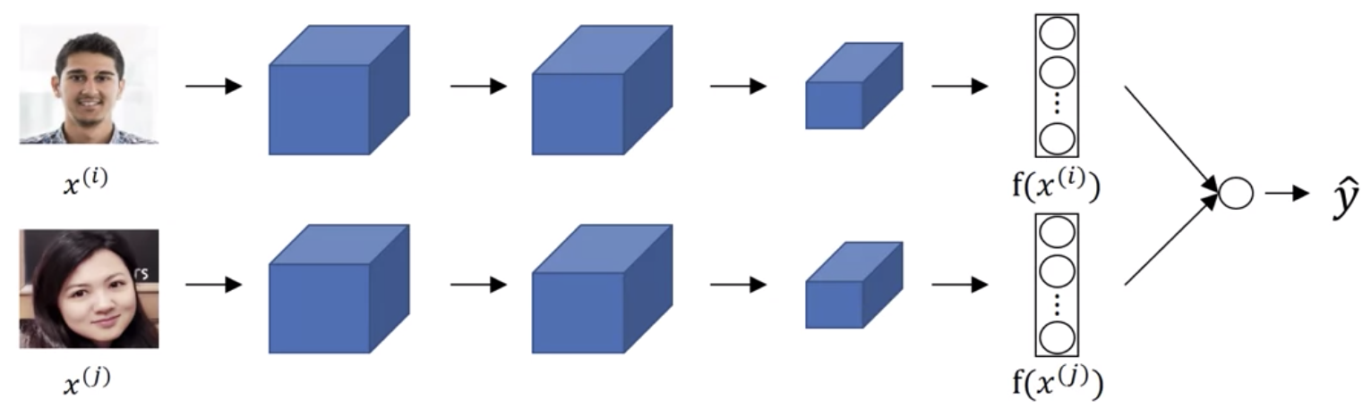

The prediction can be:
$$\hat{y}=σ\left(\sum_{k=1}^{n}{\left(W_{k}∙\left|{f\left(x^{(i)}\right)}_{k}-{f\left(x^{(j)}\right)}_{k}\right|+b\right)}\right) where n is the length of encoding$$
or:
$$\hat{y}=σ\left(\sum_{k=1}^{n}{\left(W_{k}∙\frac{{\left({f\left(x^{(i)}\right)}_{k}-{f\left(x^{(j)}\right)}_{k}\right)}^{2}}{{f\left(x^{(i)}\right)}_{k}+{f\left(x^{(j)}\right)}_{k}}+b\right)}\right)$$

You can precompute all the images in your database to store the encodings so that you only need to compute the anchor image before applying the sigmoid function.

- Neural Style Transfer

Neural Style Transfer generates an image G by combining the content of image C with the style of image S.

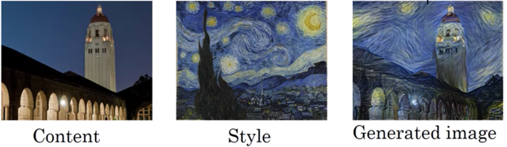

Content Cost

The content cost $J_{content}\left(C, G\right)$ measures how similar the content of the content image C and the content of the generated image G are. Let $a^{[l](C)}$ and $a^{[l](G)}$ be the activation on layer $l$ for the images C and G, respectively. The following shows how to compute the content cost.
$$J_{content}\left(C, G\right)=\frac{1}{2}{\left\|a^{\left[l\right]\left(C\right)}-a^{\left[l\right]\left(G\right)}\right\|}^{2}$$
$$Or: J_{content}\left(C, G\right)=\frac{1}{4×n_{H}×n_{W}×n_{C}}×\sum_{all entries}{{\left(a^{[l](C)}-a^{[l](G)}\right)}^{2}}$$

The shallower layers of a ConvNet tend to detect lower-level features such as edges and simple textures. The deeper layers tend to detect high-level features such as more complex textures as well as object classes. It is better to choose a middle layer in order to get the most visually pleasing results.

Style Cost

The style is defined as the correlation between activations across channels. Let $a_{i,j,k}^{[l]}$ be the activation at $H=i, W=j, channel=k$. The style matrix $G_{k,k^{'}}^{[l]}$ is used to measure how correlated the activations in channel $k$ compared to the activations in channel $k^{'}$. $G^{[l]}$ is a matrix of $n_{c}^{[l]}×n_{c}^{[l]}$.
$$G_{k,k^{'}}^{[l]}=\sum_{i=1}^{n_{H}^{[l]}}{\sum_{j=1}^{n_{W}^{[l]}}{a_{i,j,k}^{[l]}∙a_{i,j,k^{'}}^{[l]}}} where k=1, 2,…,n_{C}^{[l]}$$

The style cost measure how similar the style of the style image S and the style of the generated image G are. The style cost for layer $l$ is defined as below.
$$J_{style}^{\left[l\right]}(S,G)=\frac{1}{{4×\left(n_{H}^{[l]}{×n}_{W}^{[l]}{×n}_{C}^{[l]}\right)}^{2}}×\sum_{k}^{n_{c}^{[l]}}{\sum_{k^{'}}^{n_{c}^{[l]}}{{\left(G_{k,k^{'}}^{[l](S)}-G_{k,k^{'}}^{[l](G)}\right)}^{2}}}$$

The following shows the style cost function for all the layers. The weight $λ^{[l]}$ specifies how much layer $l$ contributes to the style and $\sum_{l}^{L}{λ^{[l]}}=1$.
$$J_{style}\left(S, G\right)=\sum_{l}{λ^{[l]}∙J_{style}^{\left[l\right]}(S,G)}$$

Cost Function

The cost function is defined below. The parameters $α$ and $β$ controls the relative weighting between content and style.
$$J\left(G\right)={α∙J}_{content}\left(C, G\right)+β∙J_{style}\left(S, G\right)$$

To find the generated image G:
- Initiate G randomly ($100×100×3)$.
- Use gradient descent to minimize $J(G)$.

